Questions exam IT soc and pro (pl to en) pre nov-2025:
In class it told that may be 1, 2, 3, 4 or none correct, if you don’t have al right is a 0 in that question. Good luck.
If you see in this questions more than 4 answers is that I joined them to save space.
1. According to IEEE-CS/ACM a software engineer is a person who directly participates in or teaches in the [field / area] of: (Slide 261)
A. software development. ✔ Correct
B. software maintenance. ✔ Correct
C. application of software.
D. theory of formal languages.
E. software testing✔ Correct
F. computer science
G. software implementation ✔ Correct
(see IEEE/ACM lists: analysis, specification, design, development, implementation, maintenance, testing).

2. The IEEE/ACM Software Engineering Code of Ethics contains: (Slide 262-306)
A. A Management section. ✔ Correct
B. A Profession & Colleagues section. ✔ Correct
C. An even number of component parts. ✔ Correct
D. In the detailed rules of the Society (PUBLIC) [section / part] there is the [principle “Acceptance of full responsibility for one’s work.” / clause “Accept full responsibility for their work”] ✔ Correct
E. Professional Responsibility section
3. The IEEE/ACM Software Engineering Code of Ethics contains: (Slide 262-306)
A. 3 component parts.
B. 5 component parts.
C. 8 component parts. ✔ Correct
D. a number of component parts divisible by 4. ✔ Correct (YES as 8/4 = 2, but VAGUE + true)

4. In Polish law co-ownership: (Slide 37)
A. may be joint or in fractional shares. ✔ Correct
B. may be partial and complete.
C. is tortious.
D. is unassailable.

5. [Ownership / Property] (Slide 35)
A. Ownership is a real property right that contains all of the following rights together: possession, disposal, use, taking benefits, and sale. ✔ Correct
B. Co-ownership may be joint, fractional, or marital.
C. [“” / The] Management of [jointly owned property / a common thing ] is possible [only under rules agreed upon by / exclusively on the basis of arrangements in the] co-owners[“” / ’ agreement] or a court [decision / judgment].
D. There exists a conservative (preservatory) [act of managing jointly owned property. / acts directed at keeping the common right (“czynności zachowawcze”); these are discussed in doctrine and case law.] ✔ Correct
E. Is a right in rem containing the listed powers: possession, disposal, use, collection of fruits, alienation. ✔ Correct
F. Co-ownership can be joint (collective) or in fractional shares. ✔ Correct
6. Intellectual property: (Slide 41)
A. is a group of legal monopolies. ✔ Correct
B. is a group of legal and economic multipoles.
C. It includes intangible goods defined by copyright law, patents, utility models and trademarks. ✔ Correct
D. the term was first used in [1788 / 1988]
E. Is a synonym of industrial property
F. Patents and trademarks are industrial property✔ Correct
G. It covers intangible goods defined by copyright law, patents, utility models/designs and trademarks. ✔ Correct
H. Patents and trademarks are excluded from industrial property.
I. the term was first used in 1888. ✔ Correct
7. Subject (object) of copyright / The subject matter of copyright: (Slide 51)
A. is any manifestation of creative activity with an individual character. ✔ Correct
B. constitutes everything that is protected by copyright law.
C. may be fixed in any form. ✔ Correct
D. It must be expressed in at least one of the [ways / manners] listed in the [act / statute].
E. It must be marked with a Copyright symbol or other authorship information.
8. Computer program: (Slide 58)
A. Every computer program is protected by copyright. ✔ Correct (99% yes)
B. In a program algorithms and problem-solving methods are primarily protected.
C. A [program that does not work can never be the object of protection / non-working program cannot be protected by copyright].
D. If it is not stated that a program is protected it is assumed the program belongs to the public domain and may be used.
E. A computer program installed in a technical device produced serially is protected by industrial property law.
F. A non-working program cannot be protected by copyright law.
G. Freeware programs are not protected by copyright law and may therefore be freely copied and [exported / exploited].
H. Algorithms constitute intellectual property and are protected.

9. Personal (moral) copyright: (Slide 93)
A. Expires 70 years after the author's death. (False as its economic copyright)
B. Is transferable.
C. Passes to the employer when the work is done within employment. (False as its economic copyright)
D. Is inheritable.
None is right

10. Copyright Duration: (Slide 110)
A. For a joint work, protection expires 70 years after the death of the author.
B. If the author outlived the others, the protection time is counted from his death. ✔ Correct
C. — (not fully visible)
D. — (not fully visible)

11. Copyright Contracts: (Slide 91-114)
A. A contract transferring copyright is an ordinary contract governed by the Civil Code.
B. If an employment contract does not state otherwise, economic copyright belongs to the employer. ✔ Correct
C. A publisher distributing software within the EU must attach a license.
D. If a license has no stated duration, it never expires.

12. Permitted use (fair use / statutory exceptions): (Slide 118)
A. Without the [author/creator]’s permission you [may/can] always use a [disseminated / published] work for [non-commercial / non-profit] purposes.
B. Without the [author/creator]’s or producer’s permission you may always use computer programs for educational purposes.
C. The circle of people [entitled to use permitted private / using any personal] use is limited. ✔ Correct
D. It does not infringe the copyright monopoly. ✔ Correct (Slide 146)
E. The circle of people using permitted personal use is not limited
F. It is allowed for didactic and scientific purposes to include published small works or fragments of larger works in textbooks and extracts. In such cases the author is not entitled to remuneration.
G. Within permitted personal use one may always use the work on all fields of exploitation.

13. Contracts (copyright):
A. A contract [transferring / for transfer of] copyright is an ordinary contract and the provisions of the Civil Code apply to it. ✔ Correct
B. If an employment contract does not state otherwise, the economic copyright belongs to the employee.
C. The author or publisher distributing a program within the territory of the European Union must attach a license to it.
D. If a license does not state a [“ “ / period of its] duration then it never expires.

14. Miscellaneous (criminal offenses related to copyright): (Slide 160)
A. Whoever [takes / collects in order to appropriate] someone else’s computer program [in order to appropriate / “”] it is subject to imprisonment from 3 months to 5 years. ✔ Correct
B. Whoever, [“” / in order]to obtain financial gain, [uses or distributes / acquires or helps to sell or receives or helps to hide an item being] a carrier of a work, artistic performance, phonogram, videogram disseminated or reproduced without authorization or contrary to its conditions, is subject to imprisonment from 3 months to 5 years. ✔ Correct
C. Whoever, without authorization or contrary to its [terms / conditions], in order to [disseminate / distribute], [fixes / records] or reproduces [another’s / someone else's] work [in multiple copies / in original form or in the form of an adaptation, artistic performance, phonogram, videogram or broadcast] is subject to a fine, restriction of liberty or imprisonment up to 2 years. ✔ Correct
D. Whoever appropriates authorship or misleads as to the authorship of [the whole / all] or part of [another’s / someone else's] work [“” / or artistic performance] is subject to a fine, restriction of liberty or imprisonment up to 3 years. ✔ Correct

15. Economic copyright (proprietary copyright): (Slide 110)
A. For a joint work it expires 70 years after the death of the author who outlived the others; the term is counted in full years starting from the year following the year of death. ✔ Correct
B. Entitles in particular to supervision over the manner of using the work. -> This is primarily a moral right (supervision), not an economic right.
C. It passes to the employer when the work is created in the course of employment. ✔ Correct
D. For jointly created software made in the public domain it expires upon its renunciation at the moment of joining such a project.

16. Liability (criminal):
A. [Who / Whoever] appropriates authorship or misleads as to authorship of a work is [punishable up to one year / subject to a fine, restriction of liberty, or imprisonment of up to 1 year]. (Up to 3 years is the correct version)
B. [Who / Whoever], for financial gain, [buys / acquires], sells, hides, receives or [assists / helps] in circulating [items / a medium bearing a work] distributed [“ “ / or reproduced] without authorization is subject to imprisonment from 3 months to 5 years. ✔ Correct
C. Who without authorization or contrary to its [terms / conditions ], for the purpose of distribution, [fixes / records] or reproduces another’s work for distribution is [punishable by / subject to a] fine, restriction of liberty, or imprisonment up to 2 years. ✔ Correct (qualified cases up to 3 years)
D. [Who / Whoever] takes to appropriate another’s computer program [is punishable by / with intent to appropriate it is subject to] imprisonment from 3 months to 5 years. ✔ Correct (the Penal Code provisions on theft/obtaining programs apply)

QUESTIONS 2025-2026:
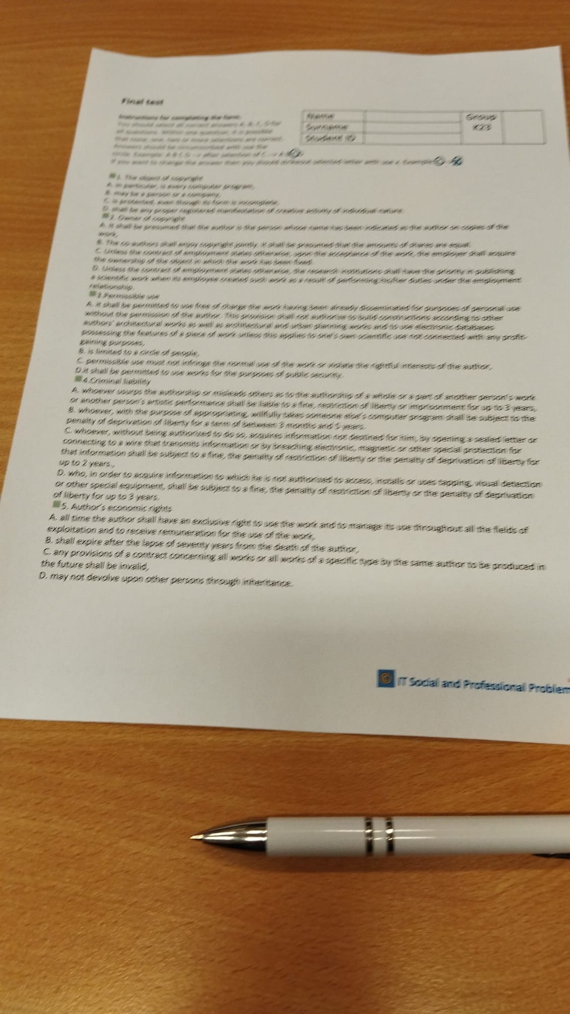
Same photo:
